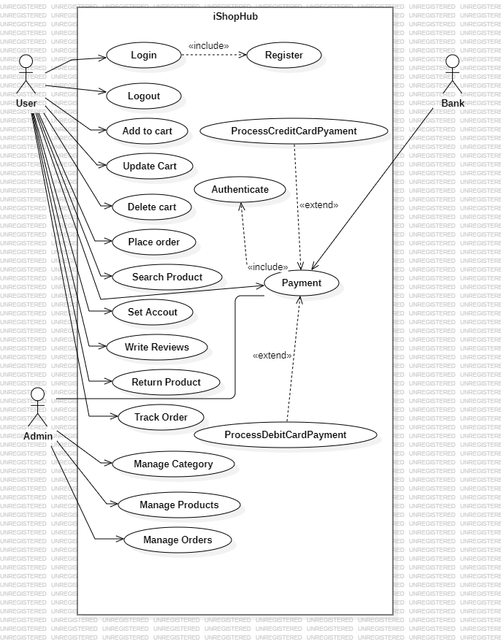Use Case diagram:

State Transition Diagram:

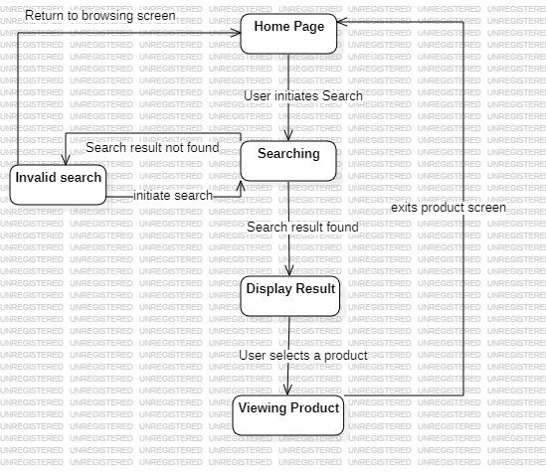

State Transition Table:

|  |  |  |  |  |  |
| --- | --- | --- | --- | --- | --- |
|  | Home page | Searching | Display Result | Viewing Product | Invalid Search |
| Home page | No | User initiates Search | No | No | no |
| Searching | No | No | Search Result found | No | Search not found |
| Display result | No | No | No | User Selects Product | No |
| Viewing Product | Exit Product screen | No | No | No | no |
| Invalid Search | User returns to browsing screen | User initiates searches again | No | No | no |

Dialogue Map:

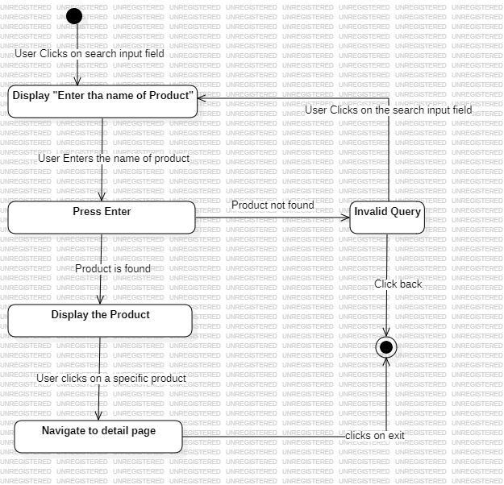

Decision Table:

|  |  |  |  |  |
| --- | --- | --- | --- | --- |
| Conditions |  |  |  |  |
| User is Logged in | F | T | T | T |
| Query Is valid | - | F | T | T |
| Product is in stock | - | - | F | T |
| Action |  |  |  |  |
| Display search Result |  |  |  | ✔ |
| Display “Please Log in” | ✔ |  |  |  |
| Display “Invalid Query” |  | ✔ |  |  |
| Display “Out of Stock” |  |  | ✔ |  |

Decision Tree:

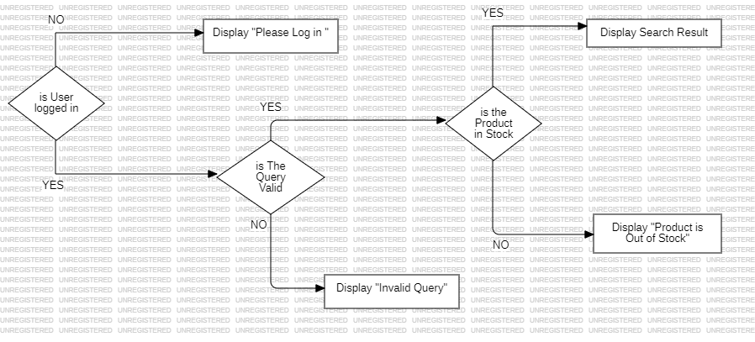

Event Response Table:

|  |  |  |
| --- | --- | --- |
| Event | System state | System Response |
| User initiates search by clicking on the search input field | Home page | System displays “ Enter the name of Product” |
| User enters the name of product | System displays search input field | System takes the input in the search filed |
| User Presses enter | System is taking input in the filed | System validates the query |
| Query is invalid | System validates the query | System Displays “ Invalid Query” |
| Products found | System validates the query | System displays product |
| User clicks on a specific product | System displays Products | System displays the detail of specific product |